Challenge

|  |  |
| --- | --- |
| **Date** | 01-01-2021 |
| **Title** | [CHANGE PROFILE] There is it should be enabled. |
| **Desc** | After upload and input cant submit  Notes:   * Tested in website   Please see attachment for details. |
| **Steps** | 1. User open website and login 2. User upload and input 3. submit |
| **Attachment** |  |
| **Severity** | Medium |
| **Priority** | High |
| **Label** | Web |
| **Reporter** | Daniel.IK |
| **Assignee** | - |

|  |  |
| --- | --- |
| **Date** | 01-01-2021 |
| **Title** | [HOMEPAGE] Image not displayed |
| **Desc** | When Website open in Home page Image not displayed  Notes:   * Tested using Google Chrome   Please see attachment for details. |
| **Steps** | 1. User Open website |
| **Attachment** |  |
| **Severity** | Critical |
| **Priority** | High |
| **Label** | Web |
| **Reporter** | Daniel.IK |
| **Assignee** | - |

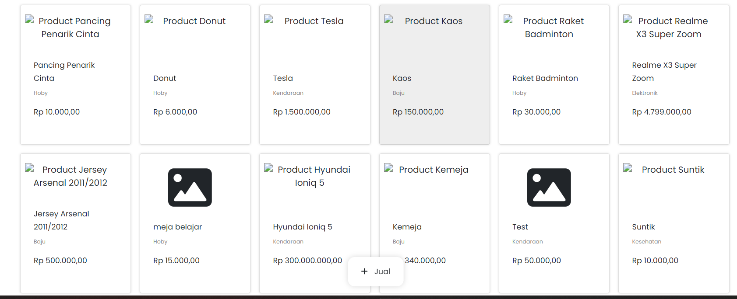

|  |  |
| --- | --- |
| **Date** | 01-01-2021 |
| **Title** | [SELLING PRODUCT] cant submit the selling product |
| **Desc** | After user input and upload the product cant be submit  Notes:   * Tested using Google Chrome   Please see attachment for details. |
| **Steps** | 1. User open website and login 2. User upload and input product 3. User cant Submit the product |
| **Attachment** |  |
| **Severity** | Critical |
| **Priority** | High |
| **Label** | Web |
| **Reporter** | Daniel.IK |
| **Assignee** | - |

|  |  |
| --- | --- |
| **Date** | 01-01-2021 |
| **Title** | [SEARCH BAR] it should be enabled. |
| **Desc** | After user open the website and login, user cant searching the product. It should be enabled.  Notes:   * Tested using Google Chrome   Please see attachment for details. |
| **Steps** | 1. User open website and login 2. User Searching the Product 3. Notice that there is disabled after fill in the search bar |
| **Attachment** |  |
| **Severity** | Critical |
| **Priority** | High |
| **Label** | Web |
| **Reporter** | Daniel.IK |
| **Assignee** | - |

|  |  |
| --- | --- |
| **Date** | 01-01-2021 |
| **Title** | [BARANG YANG DI MINATI] does not have a submit button to approve the item to be sold |
| **Desc** | After user cant approve product to be sold  Notes:   * Tested using Google Chrome   Please see attachment for details. |
| **Steps** | 1. User open website and login 2. User go to sell list 3. User go to “diminati” 4. User pick produck |
| **Attachment** |  |
| **Severity** | Critical |
| **Priority** | High |
| **Label** | Web |
| **Reporter** | Daniel.IK |
| **Assignee** | - |

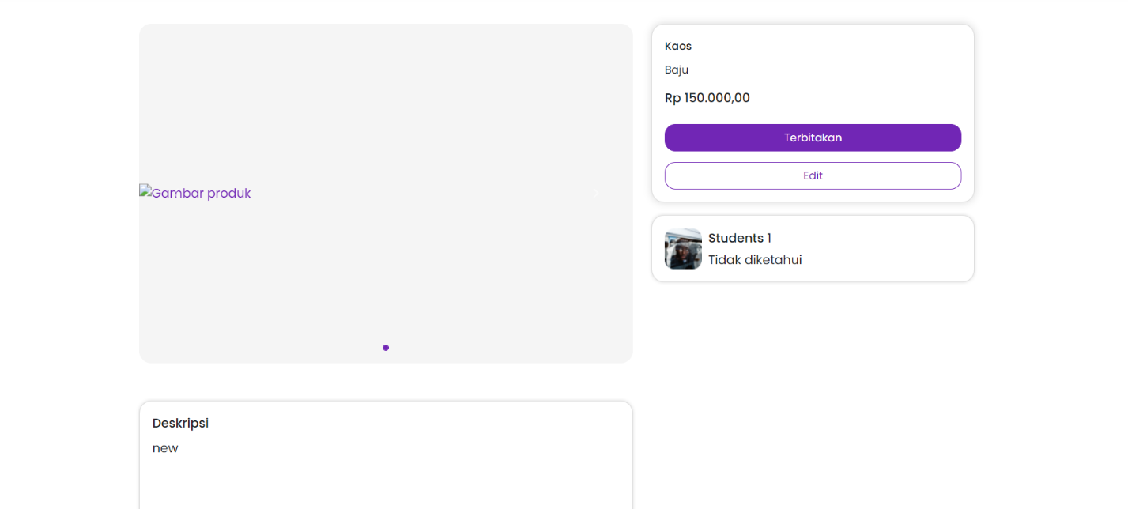

|  |  |
| --- | --- |
| **Date** | 01-01-2021 |
| **Title** | [Payment] no payment feature |
| **Desc** | After user cant approve product to be sold  Notes:   * Tested using Google Chrome   Please see attachment for details. |
| **Steps** | 1. User open website and login 2. User go to sell list 3. User go to “diminati” 4. User pick product 5. User cant paying the product |
| **Attachment** |  |
| **Severity** | Critical |
| **Priority** | High |
| **Label** | Web |
| **Reporter** | Daniel.IK |
| **Assignee** | - |